**Importing and using your new Custom Minibase**

Before completing the steps below, open Site Manager to the workspace where you will be creating your Minibase and go to the **Tools** tab at the top > **Files & Folders** and keep this window minimized.

1. Download the ZIP file attached to this email. Ensure you do not unzip the content as it must be imported in this format.

2. Navigate to the page where you wish to create your Minibase in Site Manager. Then go to the **Tools** tab at the top > **Minibase**.

3. Use the Import Configuration Button to import the ZIP file I provided.

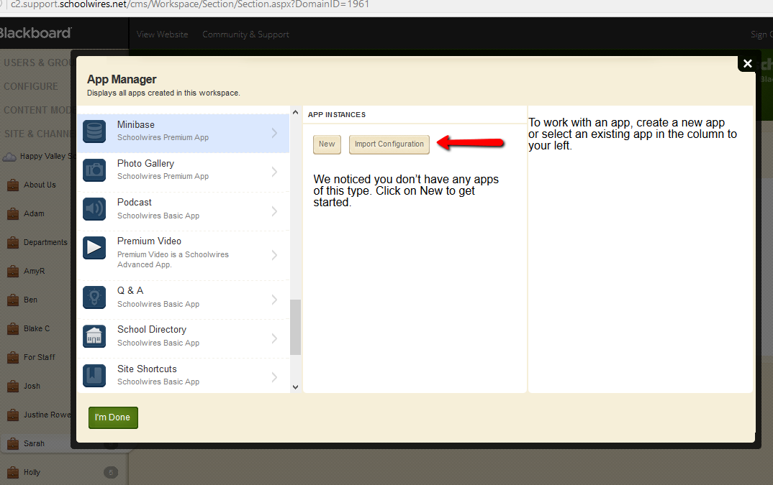

4. Click the **App Name** then the **Edit** button to open the app.

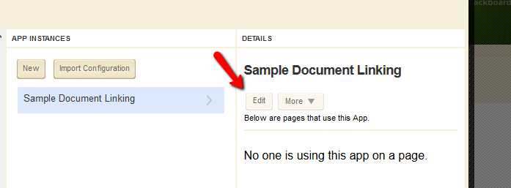

5. Go to the **Options** at the top right and rename your app. Then go to the **Custom View** tab.

6. Open the **HTML** view at the bottom of the Editor.

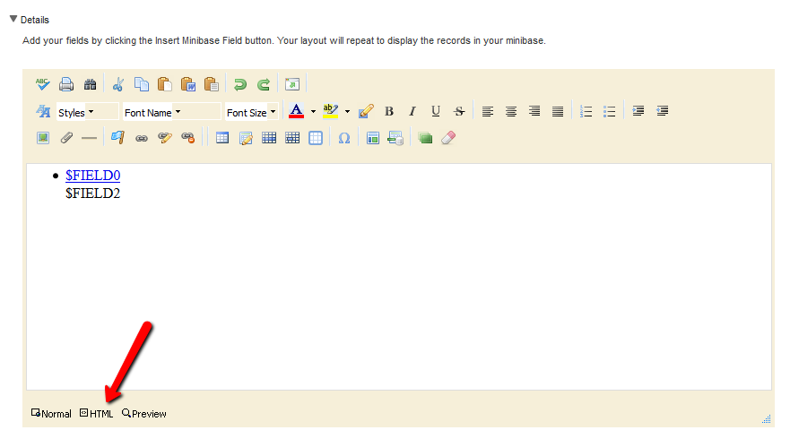

7. Maximize the **Files & Folders** workspace that you minimized at the beginning. Upload your files that relate to this particular Minibase app using the mass upload option we went over earlier.

8. Next to any file you just uploaded select **Actions** > **Get Link** then copy the **Full Web Address** field.

9. Minimize this window again and replace the highlighted HTML with the link you just copied as shown the screenshot below.

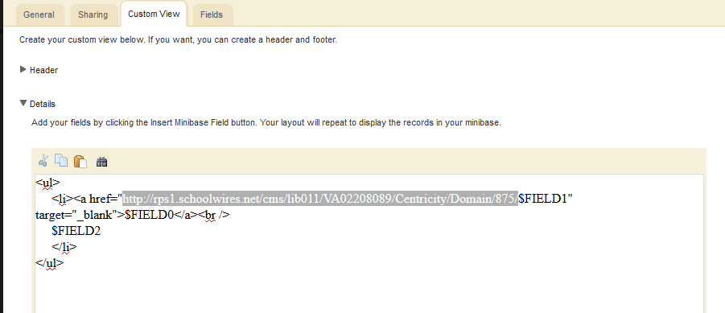

10. Remove the highlighted file name as shown in the screenshot below.

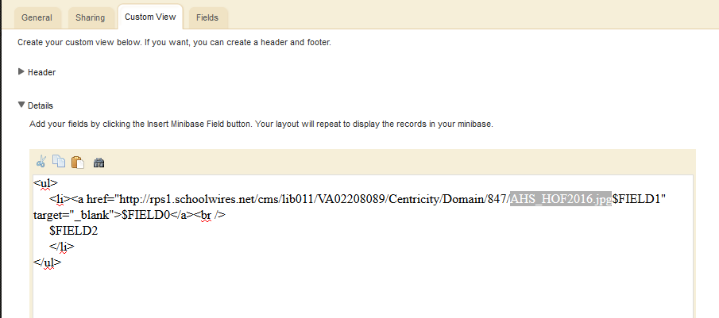

** This will update this particular Minibase to look in the folder in which you mass uploaded your PDFs to for FieldID 1.

11. Save all changes in your optins.

12. Use the attached CSV file to import the records for this Minibase app to create the links to your uploaded files.