**Work with Page Conditions**

Contents

What are Page Conditions? 2

How to Set Up Page Conditions 2

Groups: When and how to use them 4

**Blackboard Web Community Manager**

**Blackboard Web Community Manager Page Conditions**

# What are Page Conditions?

Page Conditions are used to skip pages within a form based on the answer to a previous question. For example: A question may read “Will your children be attending Happy Valley School District: Yes or No.” If the answer is “No” then they will not be required to fill out the survey. These are often used for registration forms in instances where a parent may have more than 1 child attending at the district.

When using page conditions, you want to keep in mind that you are not setting up conditions to see specific questions or pages; you are setting up conditions to skip pages within the form.

# How to Set Up Page Conditions

To begin setting up page conditions you will first need at least 2 pages within your form. The conditions will be set up at the beginning of each new page as seen in the screenshot below.

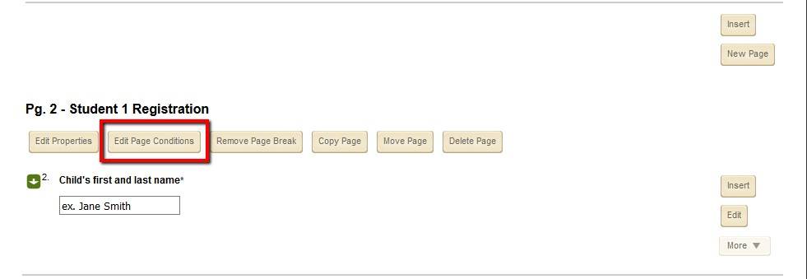

When managing your page conditions, you want to keep them as simple as possible. Only create conditions that will cause a user to skip this page. If a specific answer to a question should grant them access to this page do not worry about creating a condition.

Your condition will give you the opportunity to set up the following:

* The question that will be used to create this condition. Note that the question must be on a previous page.
* The operator of the condition such as “equal to” or “not equal to.”
* The answer that will cause the condition to run.
* The option to set which page a user should skip to.

Below you will see a condition where if a user says “No” to a question on page 1, they will skip to the end of the survey.

**Blackboard Web Community Manager Page Conditions**

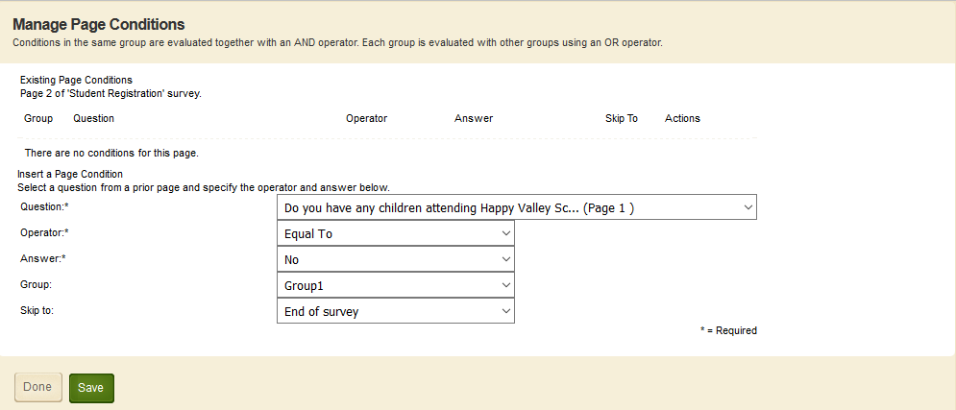

When you are satisfied with your condition use the **Save** button to add the condition to your page. Below you will see what an added condition looks like.

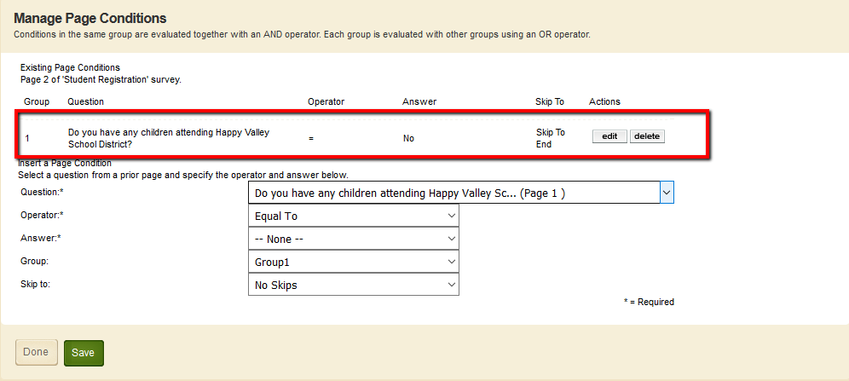

Here you can add additional conditions as needed (fewer is better) and once you are finished you want to use the **Done** button to exit the page conditions window.

*Note: When reviewing your page conditions, a default condition is added to these dropdowns. If you hit* ***Save*** *instead of* ***Done*** *when exiting this menu, it will add the default value as a condition which can affect the functionality of previously added conditions.*

**Blackboard Web Community Manager Page Conditions**

# Groups: When and how to use them

Groups give you to the freedom to create scenarios where multiple conditions must be met to skip a page, also, they allow you to create scenarios where condition A or condition B must be met.

Each group will represent an “and” condition for all conditions within the group. Below is an example of a career day signup form where a page regarding food allergies will only be relevant if the student wishes to participate in a culinary workshop AND has NO allergies.

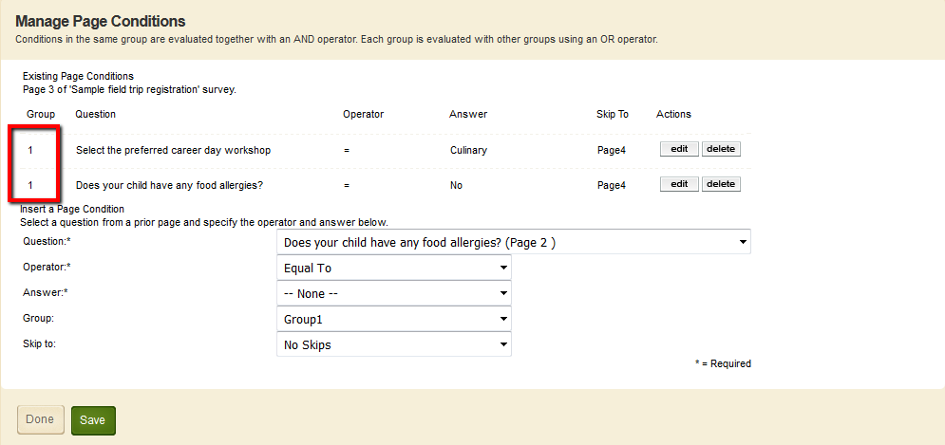

This is possible because both conditions are part of group 1.

A different scenario you may need to recreate is skipping to the same page if condition A OR condition B are met. In this scenario, the group number must be different for each condition.